Exchange Rate Maintenance

To set up an exchange rate, select Exchange Rate Maintenance from the Rate Control menu.

Obtain the noon exchange rate from the USD-CAD Noon Rate column of the Bank of Canada website. Budget usually deducts 2.5% from the given rate. For example, the exchange rate today (March 2, 2010) is 1.0326. We will offer the customer a 1.007 exchange rate following the 2.5% deduction.

In the Exchange Rate Maintenance screen, select US $ in the Currency column and type 1.007 in the Exchange Rate field. Enter today’s date (March 2, 2010) in the Valid From and Valid To fields (See Figure 1). Click Save to save your changes.

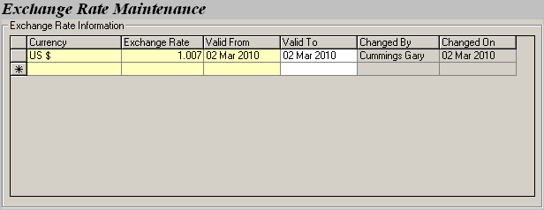
Figure 1: Recording the exchange rate.

The lower section on the screen allows you to define location specific exchange rates. Foreign locations affiliated with Budget may have a different USD-CAD rate and we can integrate their rates into our system through the Location Specific Rates section.

For example, Budget Victoria offers their customers a rate of 1.002 at their Victoria Airport location today. Once you enter and save this information (See Figure 2), all payments involving US dollars made on March 2, 2010 will follow the 1.002 rate.

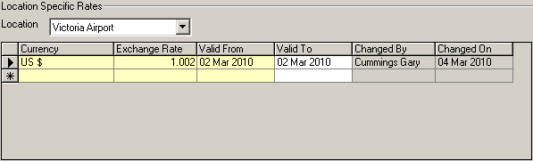
Figure 2: Entering a location specific rate.

Save all your changes once you are done.

